7-1 Discussion: Descriptive Statistics and Data Quality
Michael Surdek posted Jul 21, 2022 10:31 AM

After analyzing GE's customer churn data at a basic level and testing out a random forest model to predict customers who are likely to churn, one variable that seems particularly important is the percentage change in monthly minutes of use. This is an attribute that I would like to understand better in the hopes of using it in different ways to improve the predictive model. CHANGEM is a numeric variable that ranges from -1345 to 1244, which represent a percent change in minutes of use from one month to the next. The median of CHANGEM is about -4 and the median is about -16. This means that more customers have decreased their usage this month than have increased, and it leads me to believe that that the data is left-skewed because the mean is lower than the median. A skewness value of -0.15 strengthens this belief.
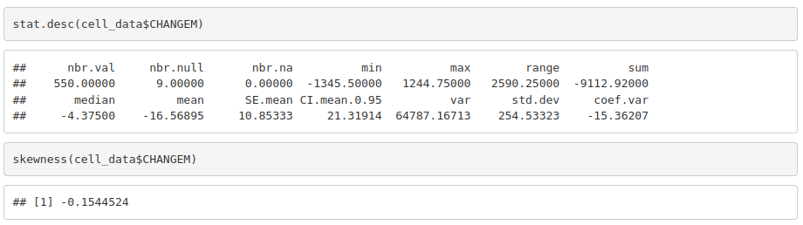

To visualize the distribution of CHANGEM, I created a histogram and split the observations based on customers who have churned and those who have not. Although it is not imminently clear, there are signs that the values are left-skewed, which makes sense because GE has seen an increase in churn, so there is likely less usage of the service overall.
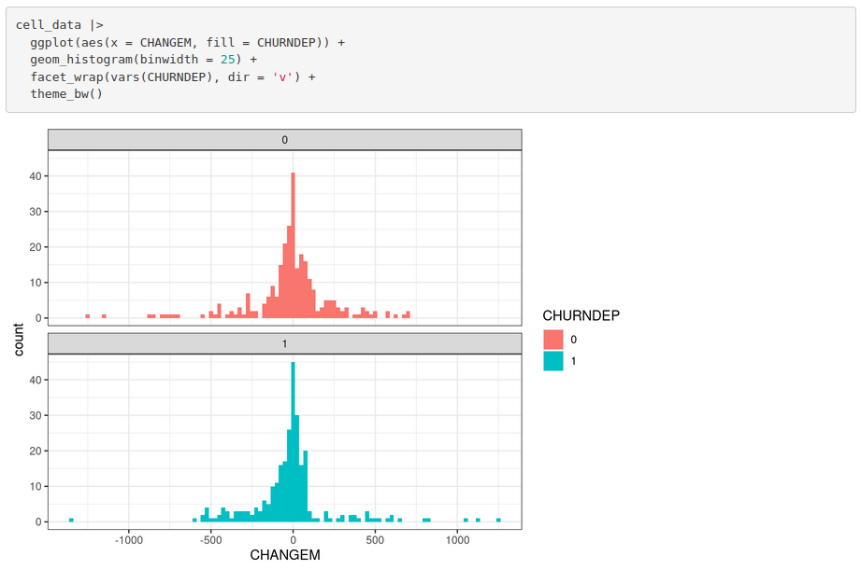

Another characteristic of the distribution that I found interesting is that most customers who increased their usage month over month did not churn. Using this knowledge might improve the accuracy of predicting customer churn. After some trial and error, I discovered that a 50% increase in usage is the optimal point where it can be said that a customer is less likely to churn. Of customers who increased their usage by at least 50%, only 39% churned and 61% did not. On the other hand, of customers who did not increase their usage by at least 50%, 54% churned and 46% did not. Based on the facts that the data set contains a 50/50 split of churn and no-churn and that the highest prediction accuracy I could get with a basic random forest was around 58%, making use of this information might improve the predictive model.
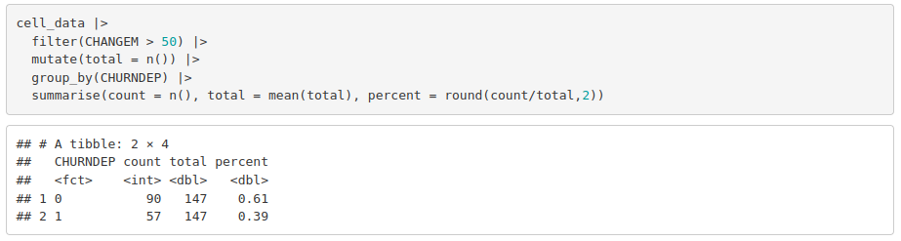
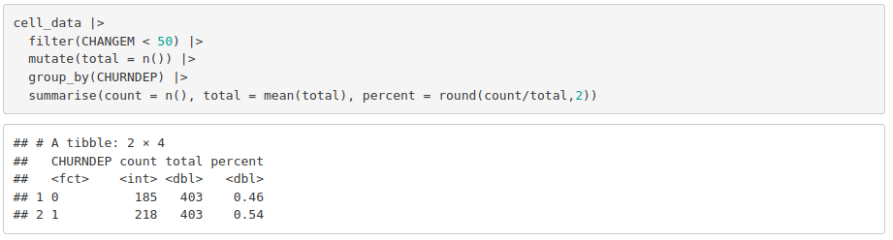
Additionally, there are some concerns that go along with the data quality and modelling techniques that need to be addressed if I wish to incorporate this information. First, the CHANGEM variable is stored as a number, but represents a percentage change. I am not sure if using a percentage would make any difference, if the results would be the same, or if the values should be standardized in some way. Second, since it represents a month over month change, at least 2 months of customer data are required to calculate a value. What about customers who are in their first or second month using the service, how can we predict that they will churn if this is such an important attribute? Finally, the 50% increase that I stumbled upon is an arbitrary cutoff. This concerns me because it may be overfitting the training and not likely to scale well to unseen data.

